SQL DML- Insert (using select) Update and delete, Transactions commit rollback and savepoint

Week #5

**1. SQL DML (5\*3-15 marks)**

* *Create a temporary table that has the employee last name, project name, and hours per week for each employee working on a project. Insert the values into the table using insert into with select command.*
* *Update the location and controlling department number of project number 10 to ‘Bellaire’ and 5, respectively.*
* *Give all employees in the ‘Research’ department a 10% raise in salary.*
* *Delete employee record whose lname =’Brown’*
* *Delete all the records of the employee who doesn’t have dependent. (use sub query).*

Ans:

* Create a database - company.

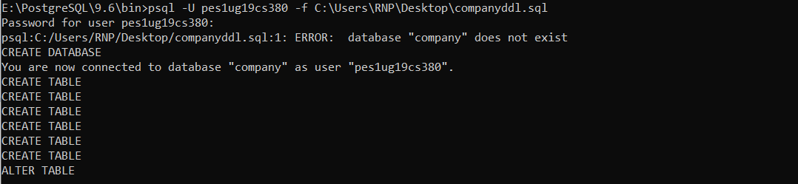

* Insert records in the tables.

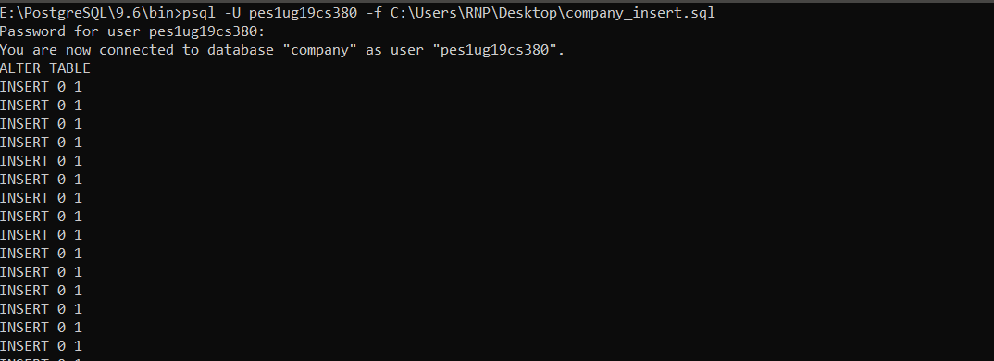

* Tables created:

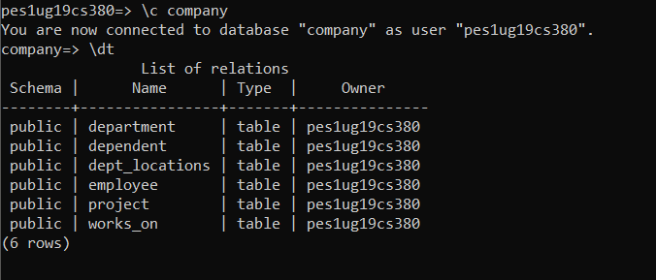

* Create a temporary table that has the employee last name, project name, and hours per week for each employee working on a project.



* Insert the values into the table using insert into with select command.

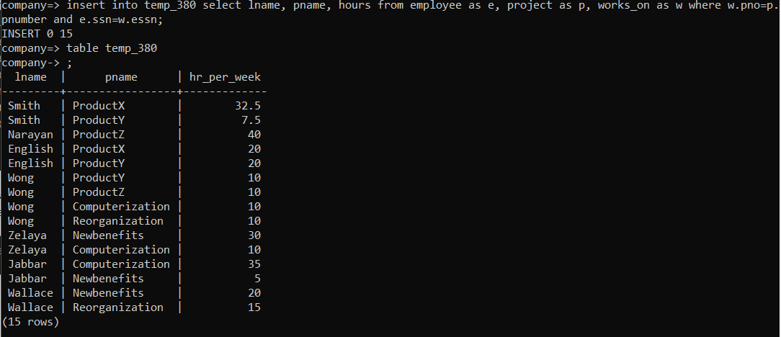

* Update the location and controlling department number of project number 10 to ‘Bellaire’ and 5, respectively

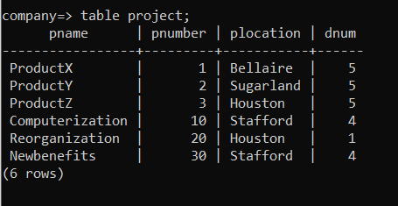

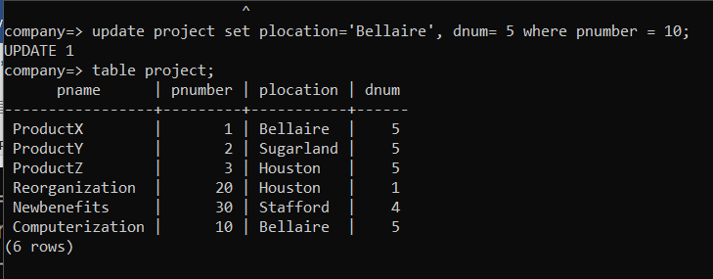

* Give all employees in the ‘Research’ department a 10% raise in salary.

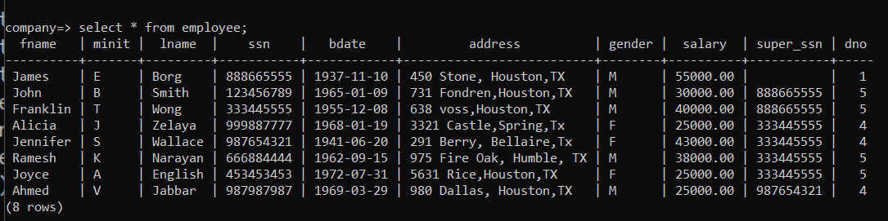

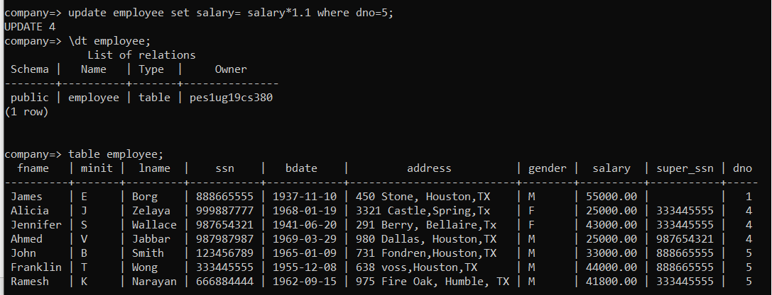

* Delete employee record whose lname =’Brown’ [no employee exists with that name, hence no records are deleted]



* Delete all the records of the employee who doesn’t have dependent. (use sub query).

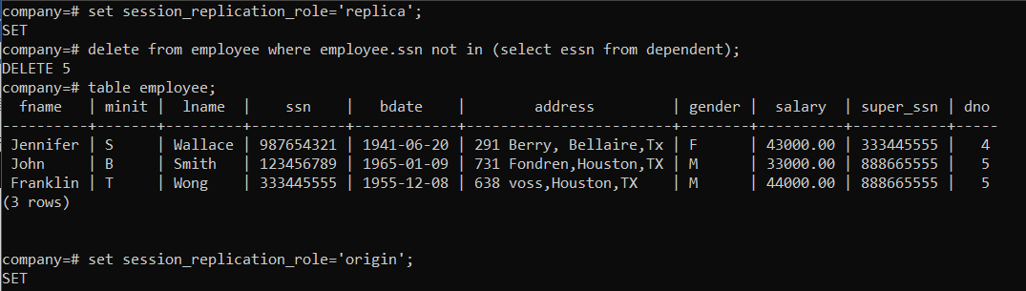

**2. Transactions (5\*3-15 marks)**

*Create a transaction using begin and end commands consisting of the following sql statements.*

* *Create a transaction consisting of a create table and multiple insert statements. After End transaction the changes should be committed and can be checked using the select statement.*
* *For the above transaction, introduce a roll back after inserting 2 records. The create and insert should not be reflected in the database.*
* *For the first transaction, introduce a save point after inserting 2 records and insert 2 more records and rollback to savepoint . The database should reflect only the first 2 insert.*

Ans:

* Create a transaction consisting of a create table and multiple insert statements. After End transaction the changes should be committed and can be checked using the select statement.

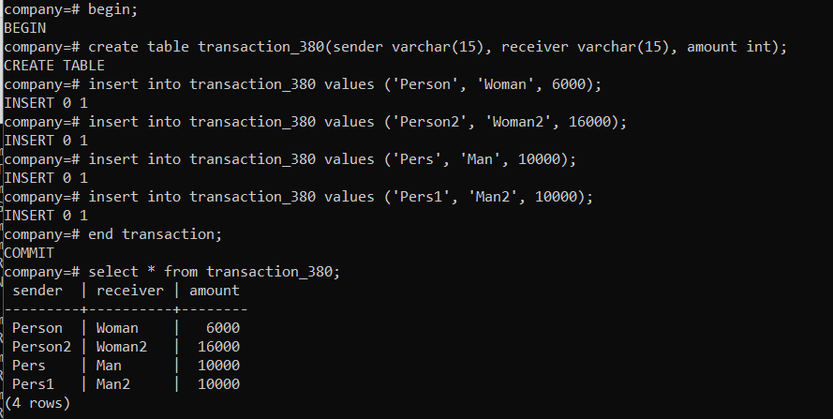

* For the above transaction, introduce a roll back after inserting 2 records. The create and insert should not be reflected in the database

*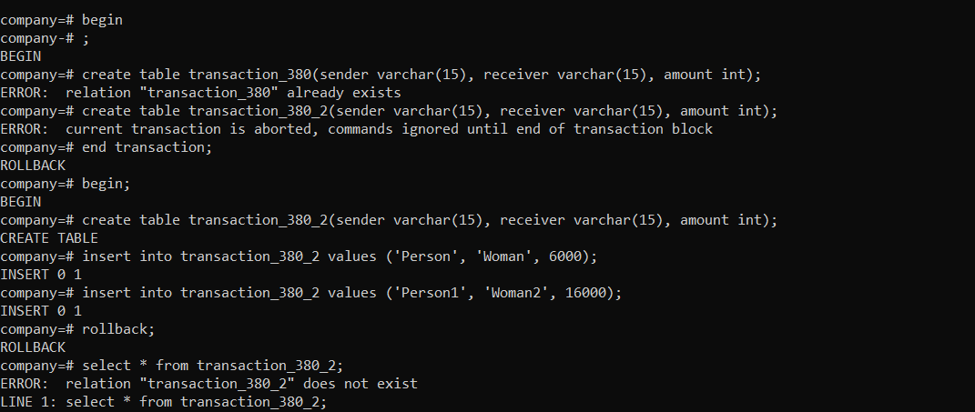*

* For the first transaction, introduce a save point after inserting 2 records and insert 2 more records and rollback to savepoint . The database should reflect only the first 2 insert

